**Calculating Family Expenses using ServiceNow**

Team Id : NM2025TMID19299

Team Size : 4  
Team Members

* Team Leader : HARIHARAN V
* Team Member 1 : HARISH C
* Team Member 2 : HEMNATH M
* Team Member 3 : HUSNA SULTANA A

**Problem Statement**

Managing and tracking family expenses is often done manually, leading to inefficiencies, lack of proper reporting, and limited visibility into financial patterns. Families require a structured way to record, track, and analyze expenses with automation and reporting features.

**Objective**

* To create a **family expense management system** on ServiceNow.
* To automate the process of updating cumulative family expenses based on daily entries.
* To enable categorization, budget tracking, and reporting capabilities.
* To establish relationships between **Family Expenses** and **Daily Expenses** tables for efficient data management.
* To ensure scalability for different family sizes and financial complexities.

**Skills**

* ServiceNow Administration
* Tables, Forms, Relationships
* Business Rules & Scripting
* Update Sets
* Number Maintenance
* Form Configuration

**TASK INITIATION**

**Milestone 1: Setting up ServiceNow Instance**

**Activity 1: Create Developer Instance**

1. Sign up at [ServiceNow Developer Site](https://developer.servicenow.com).
2. Navigate to *Personal Developer Instance*.
3. Request a new instance.
4. Fill required details and submit.
5. Receive instance credentials via email.
6. 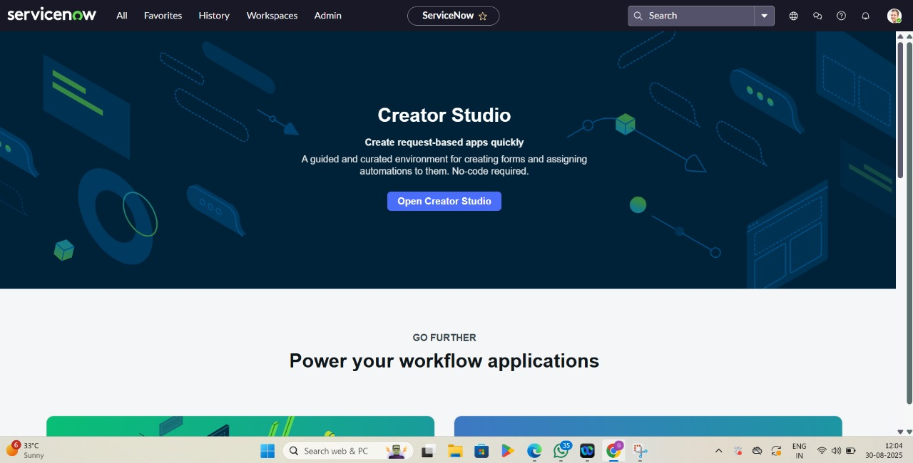Log in with provided credentials.

**Milestone 2: Creation of New Update Set**

**Activity 1: Create Update Set**

1. Go to **All → Local Update Set → New**.
2. Enter details:
   * Name: *Family Expenses*
3. Click **Submit and Make Current**.

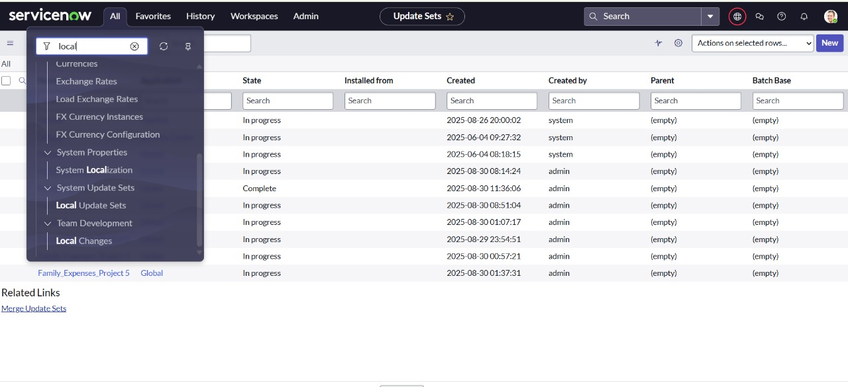**Milestone 3: Creation of Family Expenses Table**

**Activity 1: Create Table**

1. Go to **All → Tables → New**.
2. Enter details:
   * Label: *Family Expenses*
   * Name: Auto-Populated
   * New Menu Name: *Family Expenditure*
3. 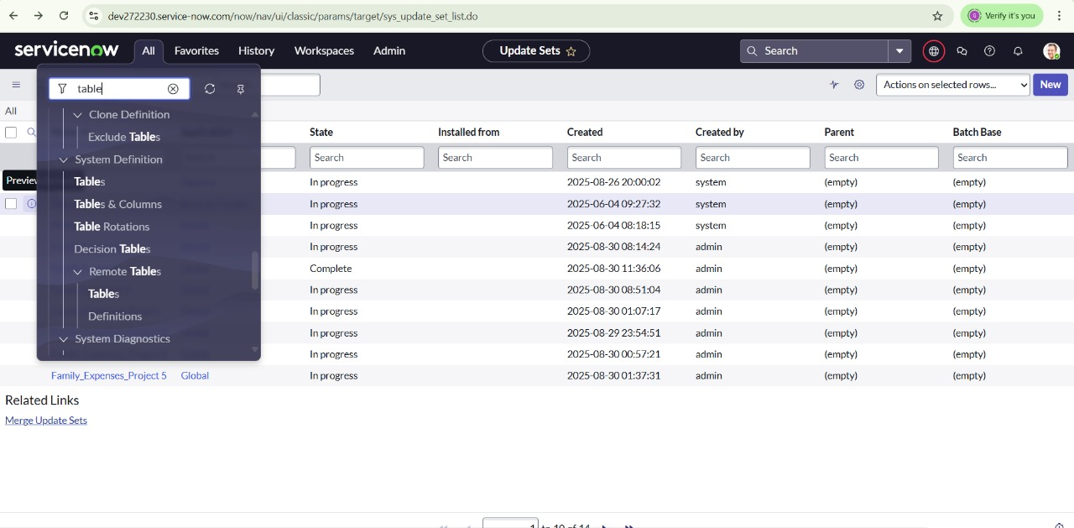Save.

**Activity 2: Add Columns**

* Number → String
* Date → Date
* Amount → Integer
* Expense Details → String (Max length 800)
* Save.

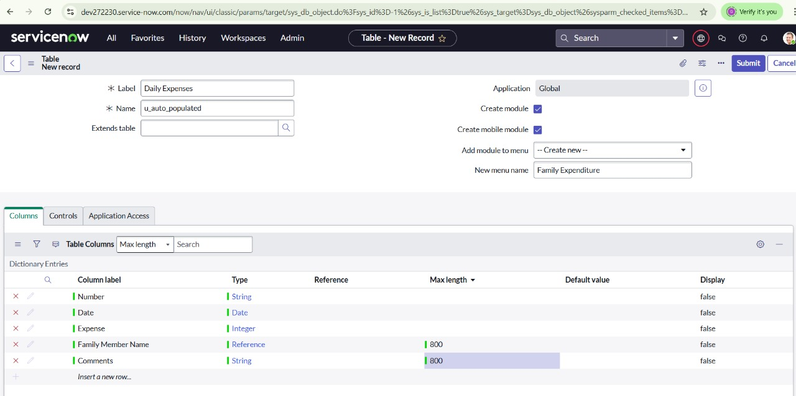

**Milestone 4: Configure Auto-Number for Family Expenses**

**Activity 1: Configure Number Field**

1. Edit **Number field → Advanced View**.
2. Set *Dynamic Default* → *Get Next Padded Number*.
3. 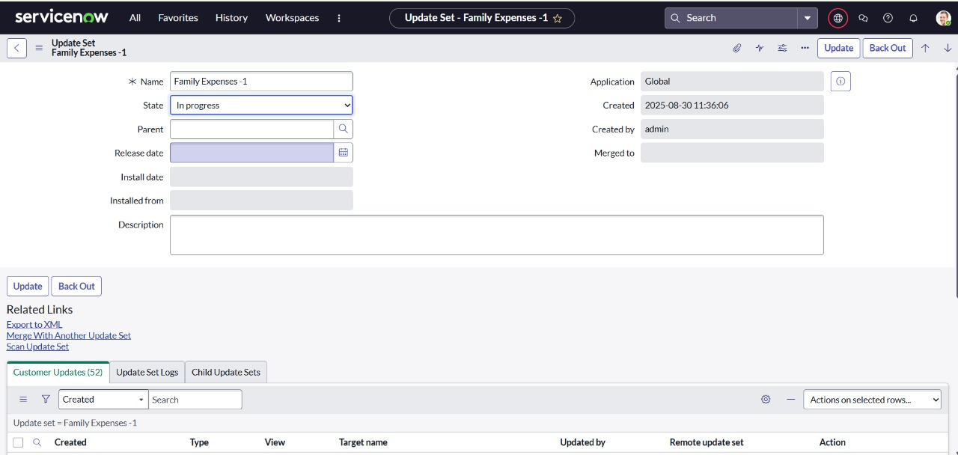Update.

**Activity 2: Number Maintenance**

1. Go to **Number Maintenance → New**.
2. Details:
   * Table: *Family Expenses*
   * Prefix: MFE
3. Submit.

**Milestone 5: Configure Family Expenses Form**

**Activity 1: Form Design**

1. Open **Family Expenses → New → Configure → Form Design**.
2. Drag/drop fields as required.
3. Set field properties:
   * Number → Read-Only
   * Date, Amount → Mandatory
4. Save.

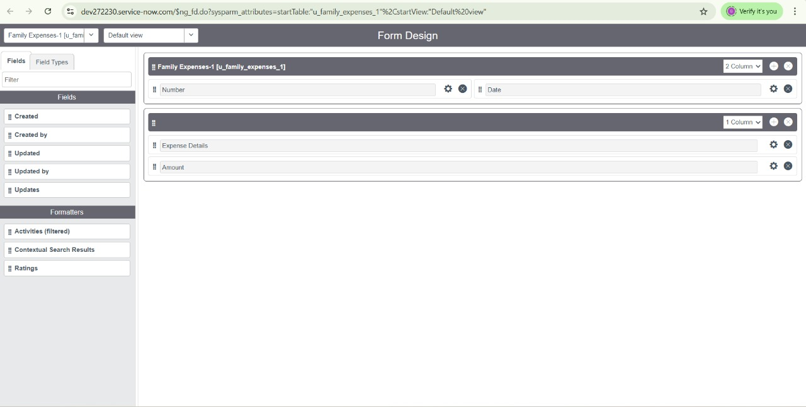

**Milestone 6: Creation of Daily Expenses Table**

**Activity 1: Create Table**

1. Go to **All → Tables → New**.
2. Enter details:
   * Label: *Daily Expenses*
   * Name: Auto-Populated
   * Add Module to menu: *Family Expenditure*
3. Save.

**Activity 2: Add Columns**

* Number → String
* Date → Date
* Expense → Integer
* Family Member Name → Reference (Max length 800)
* Comments → String (Max length 800)
* 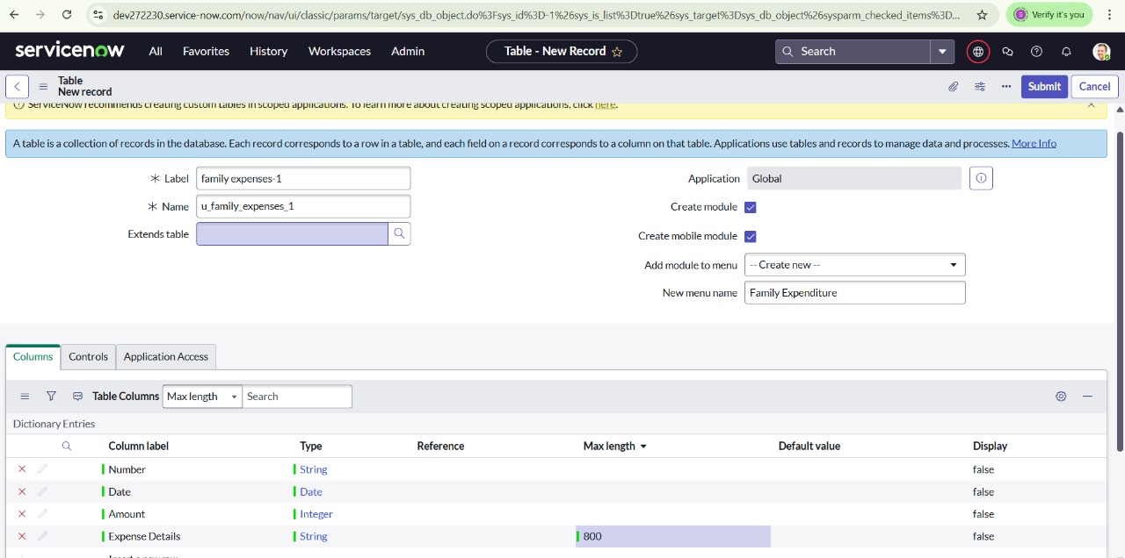Save.

**Milestone 7: Configure Auto-Number for Daily Expenses**

**Activity 1: Configure Number Field**

1. Edit **Number field → Advanced View**.
2. Set *Dynamic Default* → *Get Next Padded Number*.
3. Update.

**Activity 2: Number Maintenance**

1. Go to **Number Maintenance → New**.
2. Details:
   * Table: *Family Expenses*
   * Prefix: MFE
3. Submit.

**Milestone 8: Configure Daily Expenses Form**

**Activity 1: Form Design**

1. Open **Daily Expenses → New → Configure → Form Design**.
2. Set field properties:
   * Number → Read-Only
   * Date, Family Member Name → Mandatory
3. Save.

**Milestone 9: Create Relationship between Family Expenses and Daily Expenses**

**Activity 1: Relationship Setup**

1. Go to **Relationships → New**.
2. Enter details:
   * Name: *Daily Expenses*
   * Applies to Table: *Family Expenses*
   * Related Table: *Daily Expenses*
3. Save.

**Milestone 10: Configure Related List on Family Expenses**

**Activity 1: Related List Setup**

1. Open **Family Expenses → Configure → Related Lists**.
2. Add *Daily Expenses*.
3. Save.

**Milestone 11: Business Rules**

**Activity 1: Create Business Rule**

1. Go to **Business Rules → New**.
2. Enter details:
   * Name: *Family Expenses BR*
   * Table: *Daily Expenses*
   * Check: Advanced, Insert, Update
3. Save.

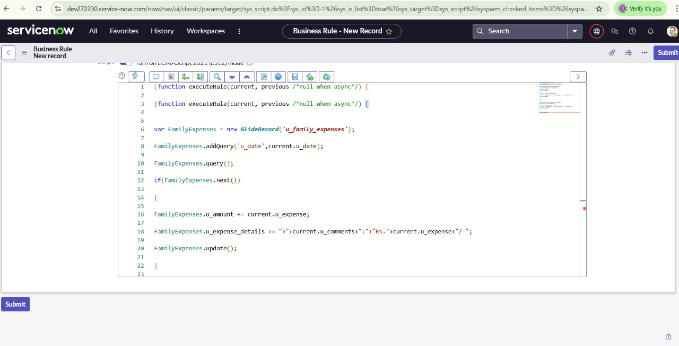

**Milestone 12: Configure Relationship Query**

**Activity 1: Query Refinement**

1. Open **Daily Expenses Relationship**.
2. Set *Applies to Table*: Family Expenses.
3. Update.

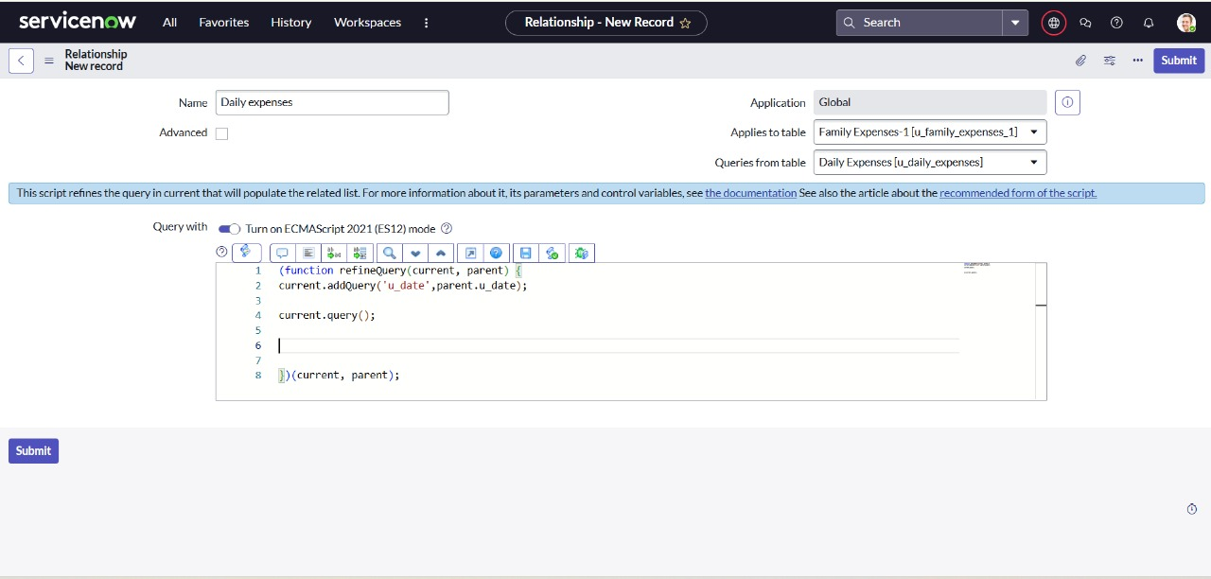

**Conclusion**

The project successfully developed a **family expense management system** using ServiceNow. By automating daily-to-family expense roll-up, creating relationships between tables, and implementing business rules, the solution provides structured financial tracking and reporting. This system is scalable and can be extended to more advanced features like budgets, charts, and predictive analysis, making it a powerful tool for financial well-being.